Beware the Iron Grip?

Exploring the Relationship Between Leader Endurance, Political Sclerosis, and National Poverty

Sean Clark

Memorial University
March 2, 2012

“The problem of Africa in general and Uganda in particular is not the people but leaders who want to overstay in power”
Yoweri Museveni, 1986

Introduction
One of the great challenges facing a society recovering from civil or international strife is to devise a political leadership both strong enough to bring stability to its war-torn lands, but also remain weak enough to keep the autocratic propensities of prevailing conquerors at bay. This is a difficult balance to achieve. After all, there is much to commend a leader’s firm hand when rebuilding a nation and its institutions, reestablishing the rule of law, and dissuading those dissatisfied with the new regime from plunging the country back into violence. Establishing an ‘iron grip’, or a system where political competition is actively curbed, can prove useful to all of these tasks. To this end, it is unsurprising that the early days of Yoweri Museveni’s authoritarian presidency went not only unchallenged by the public but were eagerly welcomed. Ugandan society had been devastated during the generation-long interregnum that preceded the Museveni’s triumph. The reign of Idi Amin (1971-79) witnessed brutal mass killings just a few months after taking power. Bodies were regularly dumped into the Nile by government death squads under the erroneous assumption that crocodiles would dispose of the evidence. In all, quarter of a million people perished. Nor was life under Amin’s successor, Milton Obote, any kinder. Another 300,000 Ugandans were killed in the bloody civil war that followed Obote’s hotly contested ascension to power in 1980. By the time Museveni’s National Resistance Army seized control in 1986, devastated Uganda ranked among the poorest countries in the world. Tellingly, the “no-party” system instituted to prevent any serious challenge to Museveni’s new regime was met with little opposition. Curbing political competition was seen as a small price to pay for a much-needed respite from the ravages of tyranny and war.
The exhausted Ugandan public was not the first to reach this conclusion. A ship caught in a storm, Plato observed, has no time for voting. Dire circumstances require hard decisions. Speed, decisiveness, and an immunity to unpopularity are essential elements of successful crisis management, and democratic leadership structures cannot easily provide them. So long as the leader is knowledgeable, the leadership literature tells us, autocrats have an easier time ensuring ‘accurate’ group outcomes than their democratic counterparts. The early years of Museveni’s rule bore testament to this, as the country went from basket case to East Africa’s poster child for economic reform. Museveni’s autocracy ended civil war in all but the far north, tamed inflation, built new roads and hospitals, massively increased the number of children in schools, and dropped the proportion of the population living on $1.25 (PPP) per day from 69% in 1989 to 38% in 2009. From iron rule came a story of notable success.
Yet perhaps a tight grip faces diminishing returns over time. “The dark side of autocratic behaviour is abusiveness, creating fear and distrust, using arbitrary and unconditional punishment, ignoring subordinates’ information and inputs to decisions, and relying exclusively on one’s own judgement.” In the long run, each of these detractions becomes more acute. Over prolonged exposure, a punitive basis for leadership can reduce group productivity and harmony. Persistent threats and coercion inevitably lead to unproductive shirking and cheating. Similarly, authoritative leaders with incorrect information can lead their groups further astray than democratic leaders with the same degree of misinformation. As many publics have learned to their detriment, a wrong-headed autocrat is extremely difficult to stop, no matter how deep into penury they have plunged the nation.
Here again Uganda provides an interesting illustration. Both in the streets and amongst the chattering classes, Museveni’s hold on Ugandan politics is considered not nearly as palatable as it once was. Starting in the early 2000s, a wave of protests has made it clear that many Ugandans have grown tired of the President’s aversion to political competition. In urban areas especially, the president now faces a degree of unpopularity previously unmatched. Protests featuring tear gas and live ammunition have become far more frequent in recent years. This much is in line with the expectations of the leadership literature outlined above. Citizens chafe under harsh, coercive rule. However, two questions remain. The first is to consider what the implications of this are on government effectiveness. More specifically, do raw aggregate metrics, such as economic growth and poverty rates, worsen the longer an autocratic government remains in power? Second is to consider what effect limited political competition has, over time, on the balance between personal and national interests. For example, recent policy decisions by the Museveni regime, such as the purchase of a £30 million Gulfstream jet, appear more in line with the president’s prestige and individual well-being than the long-term prosperity of the country. The fear is therefore that the longer a leader stays in power, the more willing he becomes to sacrifice the public good in order to maintain his own wealth, status, and prestige.
We ask these questions because while the long-run effects of autocratic leadership have been studied extensively in business and management settings, the connection to political outcomes has been almost entirely ignored. For all the tomes written on princes and presidents, there has been little rigorous theorizing about leadership and its impact on a state’s political and economic conditions. This is unfortunate, for poor leadership appears inextricably linked to the plight of a nation’s people. In Angola, Human Rights Watch has calculated that between 1997 and 2002 an estimated $4.2 billion of government expenditure went “unaccounted for,” likely pilfered by the ruling class. This constitutes an average of $700 million a year, or nearly 10% of the country’s GDP and roughly equivalent to the total sum spent on education, health, and social services over the same period. Nigeria’s oil bonanza injected $280 billion into the economy between the early 1970s and 2000. Yet wretchedly corrupt leaders siphoned most of this directly into their own pockets. Meanwhile, schools and hospitals decayed, higher education virtually collapsed, roads became pitted with potholes, the telephone system hardly functioned, and power cuts flourished. Ironically, shortages of domestic petroleum plagued the crumbling economy. In Kenya in 2010, finance officials put the losses to corruption at nearly $4 billion a year, or about one-third the national budget. Throughout Africa millions live in slums surrounded by mounds of rotting garbage, lacking access to even basic amenities, while the post-independence elite of rich politicians, officials, and businessmen—derisively known in East Africa as the ‘WaBenzi’—drive around in expensive Mercedes-Benz sedans. Altogether, the African Union estimates corruption cost $148 billion in 2002, a figure equal to more than a quarter of the continent’s GDP. It makes good sense, then, to try and understand what happens to a nation when a leader attempts to entrench himself in power, as Jacob Zuma once proclaimed, “until Jesus comes back.”

Leadership and Poverty in Uganda
Uganda makes a useful case for a leadership study because few societies in the post-independence era suffered more at the hands of their own rulers. Churchill’s ‘pearl of Africa’ is therefore tragically well-suited for an examination of the relationship between anti-competitive political systems and the welfare of the average citizen. What follows focuses on the Museveni reign in particular, partly because most of the quantitative data on government effectiveness and corruption is limited to recent years, but also because the period 1986-2012 runs the full gamut of autocratic leadership experience outlined in the literature: from eager embrace and early vigour, to growing unpopularity and worrisome decay. Museveni’s government was formed at the country’s terrifying nadir, when war and famine left a desperate public welcoming of autocratic rule. Once in power, a remarkable degree of security and prosperity was achieved in relatively short order. Over the decades, however, the regime has proven consistently unwilling to countenance the prospect of having to give their authority up, even now, some 26 years after Museveni first ascended to power. There are also some signs that the government’s once-lauded record of effectiveness has begun to deteriorate at an alarming pace. We look now to a better understanding of what the long-term effects of uncompromising leadership hold on a nation and its people.
Like many African countries, Uganda emerged from independence in 1962 with a palpable sense of optimism. After all, economic prospects looked bright. Buoyed by booming coffee, cotton, and tea exports, the country enjoyed between 1960 and 1965 the highest per capita growth in East Africa. Yet the good times would prove short-lived. Uganda’s first Prime Minister, Milton Obote, proved increasingly autocratic. Threatened with growing public and parliamentary dissent, Obote staged a coup against his own government in early 1966. He did away with the constitution and created for himself a new presidency endowed with immense powers. A prohibition of political parties followed in 1969. The General Service Unit (GSU), a secret police force stocked with Obote loyalists, was given broad freedom to arrest and imprison any suspected opponents. These moves did not, however, stifle the growing rivalry with Obote’s one-time protege and current army commander, Idi Amin. In January 1971, with Obote out of the country, mechanized forces loyal to Amin stormed key government installations and installed the general as president. Despite a promise to the contrary, parliament was quickly abolished, wiping away the last vestige of competitive politics. Soon after, the killings began. Ever fearful of an uprising by Obote’s supporters amongst the ethnic Langi and Acholi populations, Amin created the “State Research Bureau” and directed it to hunt down scores of army and police officers he suspected of opposing him.
“No one was immune. The chief justice was dragged away from the High Court, never to be seen again. The university’s vice-chancellor disappeared. The bullet-ridden body of the Anglican archbishop, still in ecclesiastical robes, was dumped at the mortuary of a Kampala hospital shortly after he had issued a memorandum speaking out about the ‘suspicion, fear and hidden hatred’ that the civilian population felt towards Amin’s forces.”
Grisly reminders of the regime’s cruelty lay everywhere. Turbines at the Owen Falls dam sometimes became choked with the bodies of victims, drifting in from the lake. As the killing increased Amin’s behaviour veered from cruelty to madness. When informed one of his former wives had been found in the trunk of her car with her limbs dismembered, Amin ordered the parts sewn back together to make possible a post-mortem viewing for him and his children.
Amin was only dethroned after an ill-conceived invasion of Tanzania invited an overwhelming counter-attack and the wholesale defeat of his army. With his troops more interested in plunder than defending the crumbling regime, Amin was forced to flee Kampala without a fight. Amin’s blundering expedition paved the way for Obote’s return, though only after a disputed national election brought fresh outrage and a bevy of guerilla groups aiming to depose him. Tragically, Obote’s second term, lasting from 1981 to 1985, would prove as brutal as Amin’s. Having watched a succession of coups before him, Obote spared nothing in the effort to ensure his own self-preservation. Genocidal sweeps were regularly conducted in the Luwero Triangle, home to many of the guerrillas who sought his overthrow. Skulls were stacked along the roadsides. In all, Obote’s ‘northern army’ stands accused of 300,000 civilian deaths. Obote’s rule was finally ended when one of his own generals, Tito Okello, revolted and forced the president and his entourage to flee, carrying as much loot as they could carry. This new military government would last less than a year, replaced in turn by yet another man arriving in Kampala at the head of an army: Yoweri Museveni.

Figure 1.0
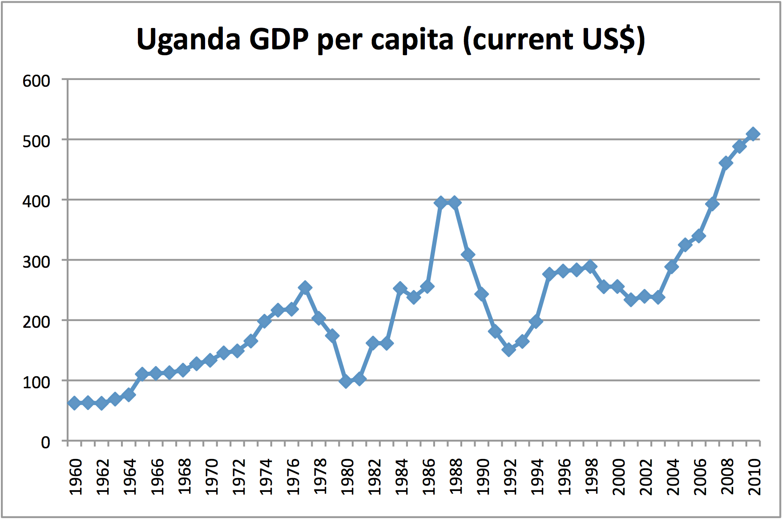
*Source: World Bank, “World Development Indicators.”

The Museveni Era
The country Museveni inherited lay in ruins. By 1986, Uganda’s manufacturing output had fallen to a third of its pre-1972 level. Incomes were 40% lower in 1986 than they were in 1971. The country had run short of essential goods, such as sugar, soap, and salt. Inflation eroded civil salaries to the equivalent of just a few British pounds a month. Agriculture production had collapsed, bringing acute hunger to the ravaged countryside. Life expectancy was declining. The World Bank described the once-promising country as “a semi-failed state with a subsistence economy.” It is thus unsurprising that when, in January 1986, Museveni’s army of 12,000 marched on Kampala, the Ankole guerilla was subject of much public adoration. Devastated by war and brutally incompetent economic management, the country yearned for stability and prosperity. Museveni’s military rule was thus not only tolerated, but in fact eagerly embraced. “Museveni declared that establishing a peaceful and secure environment was his highest priority as president. For this goal, Museveni had strong popular backing.”
Museveni’s popularity could not, however, conceal the fact that Uganda now ranked among the poorest countries in the world. Growth was stagnant and government services practically non-existent. Yet what set Museveni apart from the country’s previous generals-turned-presidents is that he turned out to be a rather astute economic manager. After some early hesitation, Museveni abandoned his Marxist education and embraced liberal economic reforms. An agreement was signed with the IMF in 1987. An ambitious series of structural adjustment and export diversification programs followed. In the early 1990s, for example, 100 of the country’s 116 public enterprises and 16 parastatals were privatized, all or in part. Another policy was to encourage Asians exiled during Amin’s regime to return. Roughly 40% of the property confiscated was eventually returned to its original owners. Museveni’s government also took seriously the notion of bureaucratic accountability. Clear standards for public sector workers were rigorously enforced. These conditions led to growing donor confidence, and more than $11 billion US in foreign aid poured into the country between 1986 and 2005. With such funds a whole series of projects became possible. Schools and roads were rebuilt across the country. One of Africa’s few successful anti-AIDS programs was launched in 1987. A program of Universal Primary Education (UPE) was introduced in 1997. As a consequence of this prudent stewardship, economic growth took off and living standards began to rise. After a 1998 visit, Bill Clinton hailed Museveni as the avatar of a “new African renaissance.”
This is not to say military rule was all roses. Human rights abuses were common. The army’s martial discipline often spilled over into civilian beatings and extra-judicial killings. Even more profound was that once Museveni and the National Resistance Movement (NRM) took power, it developed a series of mechanisms to ensure it did not fall from their grasp. The primary vehicle to achieve this was the ‘no-party’ system, wherein all political parties were banned by the government. The effect, however, was to create a one-party system, where the ruling NRM continued to plan and coordinate its activities even as all others were prohibited from doing the same. But the anticompetitive practices went beyond thwarting group organization. During elections pro-NRM candidates were provided with government cars and cash. In contrast, those who opposed the government faced persistent harassment and intimidation. The absence of parties did not, in any case, prevent the first direct presidential elections in Uganda’s history from being held in 1996. Buttressed by state resources, Museveni—already a decade in power—secured 75% of the vote. Independent observers noted that despite a good deal of chicanery the result was a roughly accurate reflection of popular opinion. The first real stability in decades and a pace of economic growth unseen since the early 1960s gave many Ugandans good reason to appreciate Museveni’s rule. Within a decade Uganda had gone from the direst straits to a country widely deemed worthy of emulation.
Neither this combination of electoral success and economic prosperity, nor the international plaudits arriving by the bushel, provided any incentive for Museveni to abandon his aversion to competitive politics. If anything, the transition to presidential elections reinforced the regime’s elaborate patronage network, which simultaneously favoured family members and loyal supporters and obstructed any real challengers. A number of high-level corruption cases in the late 1990s put this system into perspective. In 1998, for example, General Salim Saleh, brother and defence advisor to the president, was forced to resign after an inquiry discovered that, in clear violation of financial guidelines, at least $2 million in unsecured loans went to firms within which he had an interest. The inquiry also found that the general was involved in the improper privatization of Uganda’s state airline. But perhaps the most urgent warning sign came from the regime’s involvement in the Congolese civil war. There, after failing to oust his former proxy, Laurent Kabila, Museveni moved with Rwanda’s Paul Kagame to make the eastern Congo a military fiefdom. Some 15,000 Ugandan troops were deployed in 1998. They set almost immediately to plundering the region’s rich resources. Local militias were trained by the army and rebel “administrations” were set up in order to tax local inhabitants. In what proved to be a highly lucrative business, aircraft would arrive from Ugandan military airfields with consumer goods, foodstuffs, and arms, then depart loaded with Congolese diamonds, coltan, and gold. Rwandese forces did the same, though with a subtle difference: while the Rwandan government exercised tight control over its forces’ moneymaking operations, the Ugandan army was given free reign to make private fortunes. At the forefront of the beneficiaries were key members of Museveni’s family, including—once again—General Saleh.
If the war in the Congo exposed the more nefarious aspects of Museveni’s once-lauded regime, domestic events over the last decade and a half have reinforced the diagnosis of an ossifying leadership. In 1998, the influential Economist magazine spoke of gathering “clouds of doubt” gathering over the erstwhile success story. The primary concern was the looming spectre of corruption, a problem which had grown to the point that aid donors estimated corruption cost the country $200 million in 1999 alone. In 2005, health charities suspended grants to Uganda, citing allegations of financial mismanagement. In 2008, two senior cabinet ministers unduly used their political influence during the sale of roughly $6 million US of land. In 2010, the EU cut budgetary support amid fears members of the regime were pocketing much of the aid. Throughout the country, government officials charge additional fees for services and then pocket the cash. Police accept bribes to ignore traffic violations. Corrupt military officers collect the pay of “ghost” soldiers; recruits either now dead, deserted, or works of pure fiction. Perhaps most remarkable of all is how diplomatic cables released by Wikileaks in 2010 revealed that corruption allegations reach as high as the president himself. This is perhaps unsurprising, given that corruption, in the words of a leaked World Bank report, “has become a mechanism for regime maintenance.”
The mounting evidence of a government more interested in personal accumulation than the national good coincides with a series of ever more overt efforts to thwart serious presidential rivals. Indeed, the shift to direct presidential elections in 1996 has been followed by anything but open political competition. Not even the decriminalization of political parties in 2005, following extensive pressure from international donors, has managed to stem the NRM’s willingness to subvert the democratic process. This fact is well illustrated by the last several presidential elections, beginning in March 2001. By this time dissatisfaction with the regime had grown to the point where Museveni faced, for the first time in 15 years of rule, a credible challenger. The opponent was Dr. Kizza Besigye, once Museveni’s personal doctor and a former NRM commissar. The NRM did not, however, take the newfound competition kindly, and the regime’s grip noticeably tightened:
“Feeling himself threatened, Mr Museveni pursued a heavy-handed campaign, calling in the army to help the police. Soldiers were seen manhandling opposition agents, and even opening fire. As tensions increased, Mr Museveni…attacked Dr Besigye for having AIDS.”
The strong-arming proved sufficient for Museveni to carry 69% of the vote against Besigye’s 28%, albeit with considerable and well-substantiated voter intimidation and vote-rigging. Yet the victory did not leave Museveni in a magnanimous mood. Immediately following he announced that it was time to begin assigning cabinet positions based on the regional support shown him, a claim which strongly contradicted his longstanding assertion that non-party “movement” politics was justified on the grounds it was broad-based and inclusive. Nor did the win lead to a slackening of the government’s pressure on the opposition. In fact, the opposite was true. In 2002, after a report detailing the army’s stalled offensive against the LRA in the north, police barged into the independent Monitor newspaper offices and shut down the presses. This was a bold stroke for a regime previously lauded for its media tolerance. Besigye’s response was to openly contemplate civil war, telling his followers via a radio call-in show in August 2002 to “train and wait” for his call to arms. The government’s response was similarly grim. A 2004 report by the lobby group Human Rights Watch found that opposition activists were routinely tortured, typically taken to secret ‘safe houses’ and forced to lie under running taps with their mouths open or beaten with hammers.
Besigye’s rebellion never came, but tensions continued to rise. In June 2005, Museveni prodded a malleable parliament to amend the constitution of 1995, which forbade more than two presidential terms. The following August, Andrew Mwenda, one of the country’s best known and most outspoken journalists, was arrested on the charge of sedition and thrown into jail. His radio station, KFM, was shuttered by the authorities as well. The president then threatened to again shut down the Daily Monitor and two other independent newspapers for good measure. Such media-bashing was merely a prelude to the heated 2006 presidential election, a campaign marred by the arrest of Museveni’s main rival, Dr. Besigye, on trumped-up treason and rape charges. The official results found Museveni to have won 59% of the poll on a turnout of 68%. Foreign observers reported that the election process itself was “broadly fair, despite some irregularities,” although they criticized the “absence of a level playing field for all candidates during the election campaign.” The charges against Besigye were eventually thrown out by the country’s Constitutional Court.
This did not, however, convince the regime to embrace pluralism, for the subsequent February 2011 presidential election was similarly considered an unfair contest. Amnesty International recorded numerous instances of electoral violence, though the crimes were never investigated, nor were suspected perpetrators brought to justice. Key opposition leaders had public rallies and media events, particularly radio talk shows, cancelled or blocked by the police and government representatives. The result was another victory for Museveni, winning 68% of the vote against Besigye’s 26%. Although voter turnout was dismal, it is interesting that most observers noted this campaign lacked the same degree of thuggishness that so coloured the 2006 election. Besigye and other opposition candidates were permitted greater freedom to campaign, and the press felt less bullied. Unlike during the previous election, “Mr Museveni appeared not to need ghost voters or local officials to fabricate results in his favour.” Instead, Museveni’s 2011 win seems to have been predicated on the distribution of money throughout the NRM’s crucial rural base. “Envelopes of cash were handed out to peasants, teachers, and local officials up and down the country.” The prospect of a share of Uganda’s future oil revenues brought others into the fold. So too did a concerted effort to tempt members of the opposition group Forum for Democratic Change (FDC) to cross the floor with cabinet and other official posts. Some, like Museveni’s old Ntare schoolmate, Eriya Kategaya, accepted the offer.
That the Museveni regime proved as adept at co-option as physical coercion should not mask the fact the government’s grip remains strong. This was demonstrated just a few short months after the 2011 elections, when rising food and fuel costs sparked a series of “Egypt style” protests. Initiated by the organization Action for Change, participants were asked to walk to work that April en masse as a means of protesting skyrocketing prices, persistent unemployment, and corruption. The government’s response marked a new low in the regime’s tolerance for political competition, as military police attacked unarmed protesters using tear gas and live bullets. At least eleven people were killed and more than 480 wounded, with Besigye and other opposition politicians repeatedly beaten and detained. Scores more were jailed by the authorities. In October, a second wave of ‘Walk to Work’ protests took place, greeted once again by rubber bullets and tear gas. That same month the Uganda Human Rights Commission reported that incidents of torture and ill-treatment by the police and other security agencies, including the military, remain widespread. Meanwhile, Museveni has been steadily improving the capabilities of the Presidential Guard Brigade, an elite force estimated at more than 10,000 members. Their loyalty, it is widely assumed, is directly to the president.

The Relevance of Leadership Sclerosis
Throughout its existence the Museveni regime has maintained a tight grip on power. Not even a shift to democratic elections did much to reduce its ability to curb political competition. According to Freedom House, political and civil liberties in Uganda are as constrained today as they were under the early days of military rule. In this light, the government’s instincts of self-preservation have been remarkable, with any threat to Museveni’s rule thus far effectively co-opted or physically suppressed. Over time, however, we can anticipate two direct consequences of this authoritarian triumph. The first is that anticompetitive behaviour tends to be reinforcing. Doing away with political opposition in times of emergency reinforces the idea that it is nothing more than an unnecessary encumbrance, even when the national danger has passed. A subsequent shift to democracy is therefore likely to be only half-hearted, with the government’s rivals treated with disdain, if not outright repression. At the paranoid extreme, the mere expression of political dissent is interpreted by rulers as treachery, and treated by the security forces as such. In either case, public dissatisfaction with the government will broaden, driven in part by increasing displeasure with such heavy-handed rule. This rising anger will be exacerbated by a second dynamic. Over time, the absence of political competition almost invariably brings about worsening government performance. This is because the longer an iron grip is maintained, the less a leader fears reprisals for his pursuit of self-enrichment. Behaviours such as corruption and the plundering of state resources become much more palatable when there is no danger of requital. The effect is to incentivize personal accumulation, even to the detriment of national interests. We should therefore expect the longer a political system remains uncompetitive, the less of a priority the effective provision of public goods and services will be.

Figure 2.0 (note: based on public perceptions score)
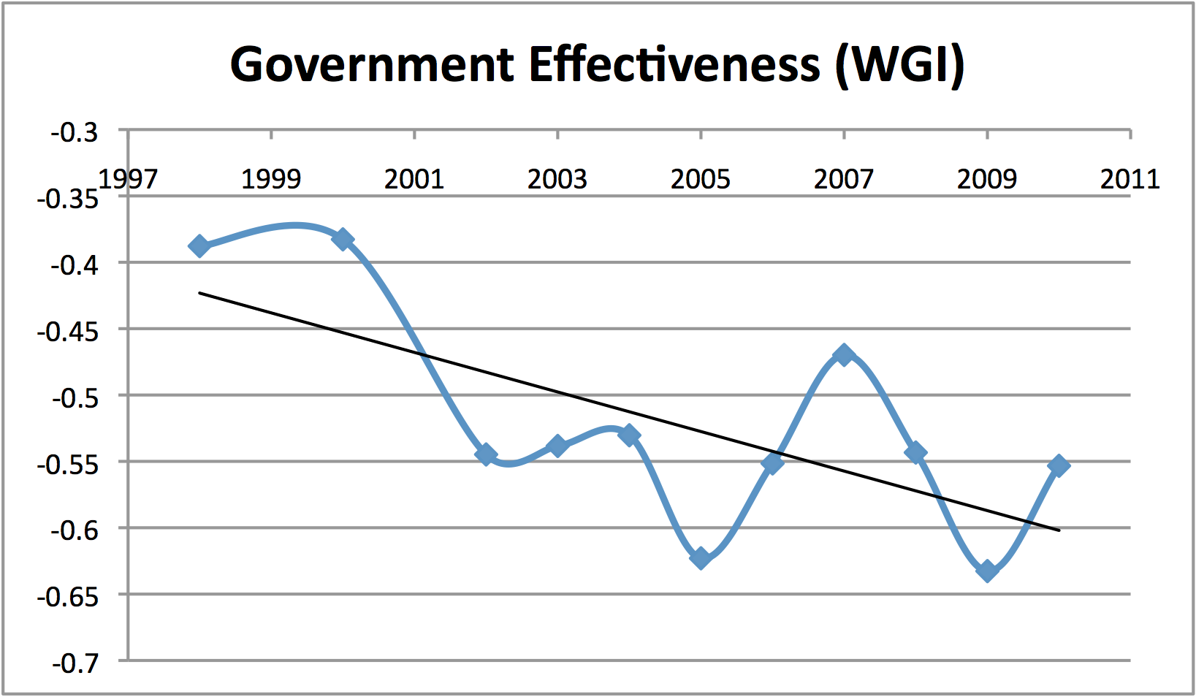
*World Bank, “World Governance Indicators (WGI),” 2010.

This model has certainly been borne out in Uganda. According to World Bank figures illustrated in figure 2.0, public perceptions of the government’s effectiveness have worsened steadily in the years following the 1996 election. Lacking any real check on the regime’s power, Museveni and his colleagues have been free to deviate from previous commitments to good governance. The absence of a viable political opposition enables such transgression to proceed without punishment. The effectiveness of public policy has deteriorated in turn, a conclusion substantiated by a wide array of additional evidence. Corruption, for example, has proven a consistent scourge. As illustrated in figure 3.0, data collected by Transparency International points to a disheartening trend. Their research indicates perceptions of corruption noticeably worsened in the late 1990s, improved in time for the 2006 election, but then fell steeply shortly thereafter. That corruption today is worse than the beginning of the post-1996 election cycle is alone indicative of leadership sclerosis. Even more dramatic, however, is when the fight against corruption is considered in regional perspective. In this light the results look even bleaker. Compared to the strides made by its neighbours in combating graft, Uganda appears as a laggard, dropping in just a few years from the 57th percentile of African performers to 40th. Nor does the problem show any sign of abatement. In October 2011, embezzlement fears drove parliament to suspend all new deals in the oil sector, uncertain as it was just who was going to benefit from harvesting the country’s substantial, but as yet untapped, oil wealth. Further self-enrichment schemes are likely to be uncovered.

Figure 3.0 (note: a lower CPI indicates a greater level of corruption)
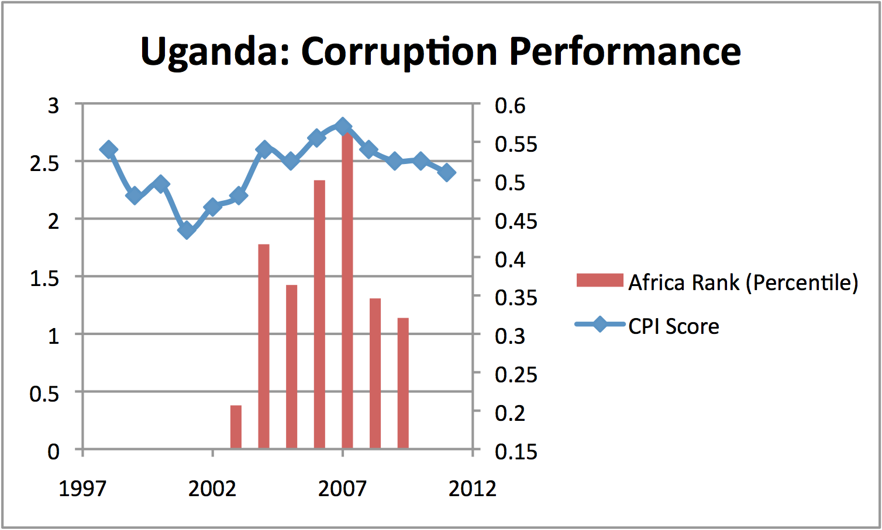
*Source: Transparency International, annual reports; World Bank, “African Economic Review”; and author’s calculations.

Qualitative measures tell a similar story. Notable is the evaporation of the country’s once-bullish economic prospects. The pervasiveness of corruption and waste in particular have dealt a sharp blow to the confidence of the country’s commercial and working classes. Residents hear of expensive new spy drones while driving to work on roads cratered in potholes. Government ministers stand accused of pilfering millions of dollars in shady land deals while the number of available hospital beds has sharply declined. Public spending on education, as a percentage of total government expenditure, dropped from 18.8% in 2008 to 15.0% in 2009, even though the government sought fit soon after to spend $700 million on Russian interceptors. In order to pay for lavish swearing-in ceremony for Museveni’s latest election victory, a supplementary budget request for $12.5 million was tabled in parliament, all while crucial public services wither from neglect. “Kampala suffers rolling blackouts, partly because the government has failed to pay its fuel bills, and yet street lamps burn uselessly during the day.” Transport and energy infrastructure, particularly the connection to the vital Kenyan port of Mombasa, has suffered from years of chronic underinvestment. Just 10% of Ugandans are connected to the power grid. Perhaps most ominously, “Only about a fourth of the four hundred thousand new entrants to the Ugandan labor market find formal employment; the rest enter the informal economy, where wages are minimal and survival is a struggle.”
Standing above all of this is a president who no longer offers much in the way of sound economic policy. Once lauded for his economic pragmatism, Museveni now routinely conflates population growth with market growth, and jaws constantly at the international donors who have done so much to help bring about the country’s dramatic revival. Instead of offering solutions to the country’s growing inflation and unemployment problems, the president chastises protesters as “drug users” and trivializes their plight. What is worse is that this deficit of leadership has veered into outright economic vandalism. Aid organizations now fear that the government’s recent spending spree has been fuelled by either raiding the reserves at the Bank of Uganda or printing new money. Museveni's reelection campaign alone is estimated to have cost $350 million. Given Uganda’s average life expectancy grew by just four years between 1970 and 2010, it is easy to imagine more productive ways to spend such a large sum. Acts of self-preservation and self-enrichment, in other words, come at a massive opportunity cost to the national good.
The idea of opportunity cost is a crucial one. It is true that even in the face of the 2008 global recession and its turbulent aftermath, Uganda can claim a good deal of success in reducing the national poverty rate from its catastrophic highs of the early 1990s. Just two decades ago some 70% of Ugandans lived in conditions of the deepest destitution. Hunger stalked the countryside. These ranks have been substantially thinned by two decades of steady income growth, a feat achieved at a much faster pace than the Sub-Saharan average. However, two chief problems remain. First, a great deal more work remains to eliminate even this most extreme form of poverty. Almost 40% of the population still lives on less than $1.25 (PPP) a day. Even more effort is required to provide the population with merely with a moderate income level, according to international standards. At current trends (that is, 3.2% annual population and 7.2% GDP growth averages for the period 2000 to 2009) it will take almost two decades to reach the ‘middle income’ status of $1,000 US earnings per year. Second, as figure 4.0 illustrates, Uganda’s performance pales in comparison to what the developing nations of East Asia have been able to achieve. That region’s poverty reduction efforts have gone much further and much faster. Uganda’s achievements therefore leave much to be desired.

Figure 4.0
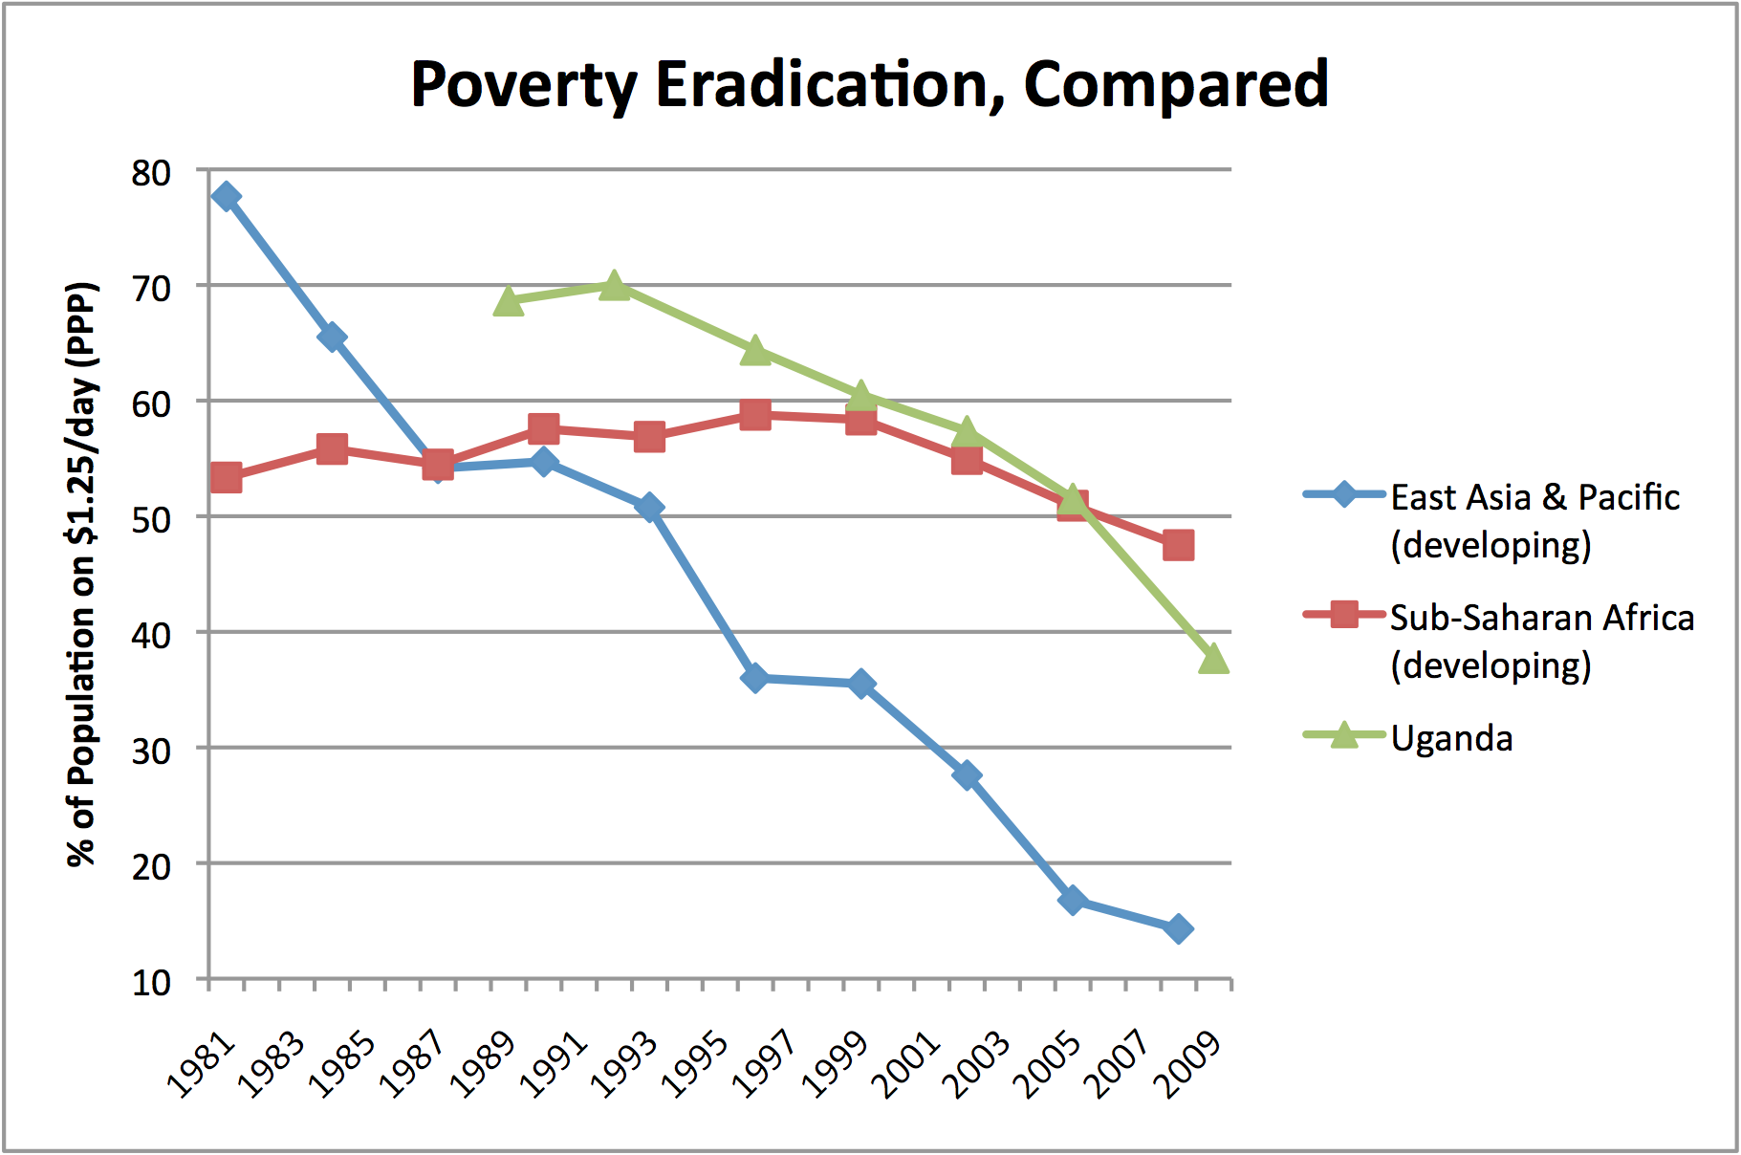
*Source: World Bank, “World Development Indicators” and “PovCalNet Interactive Poverty Analysis Tool.”

The fact is Uganda’s economy simply cannot afford to slow down. Continued high rates of growth are imperative, given not only the need for further poverty reduction, but also just to maintain previous gains. A stubbornly high birthrate has left Uganda with the world’s youngest population. With more than half the citizenry under age 18, population will continue to grow rapidly: the projection is a doubling between 2005 and 2030. Uganda’s economy therefore needs to expand at least 3.2% per year—roughly the current rate of population increase—just to keep pace with all the new mouths to feed. Anything less and living standards will decline. The easiest way to think about the impact of demographics is figure 5.0, where population growth has been graphed alongside the rate of economic expansion. The population line can be seen as a crucial threshold: growth rates above the plot line indicate incomes are rising; rates below signal the contraction of living standards. The effect of such rapid population growth is to greatly slow the pace of poverty elimination. This is certainly true in comparison to Asia, where keeping fertility rates low has monopolized the fruits of economic gains for the current population. Take China, where population growth is currently less than half a percent. In this way almost all the country’s economic growth is devoted towards expanding incomes. Whereas in Uganda, with a population rate of over 3%, the previous decade’s average rate of 7% GDP growth is almost halved in effective terms. This is part of the reason why poverty reduction has proceeded so much more slowly in Uganda. It is also an indication of just how crucial it will be to maintain robust economic expansion going forward. With population growth so high even a moderate recession devastates incomes. It is therefore deeply troubling that Uganda’s economic performance has been declining steadily over the last half decade. This trend desperately requires immediate reversal. It remains to be seen, however, if Uganda’s sclerotic leadership is up to the task.

Figure 5.0 (note: GDP growth is in real terms).
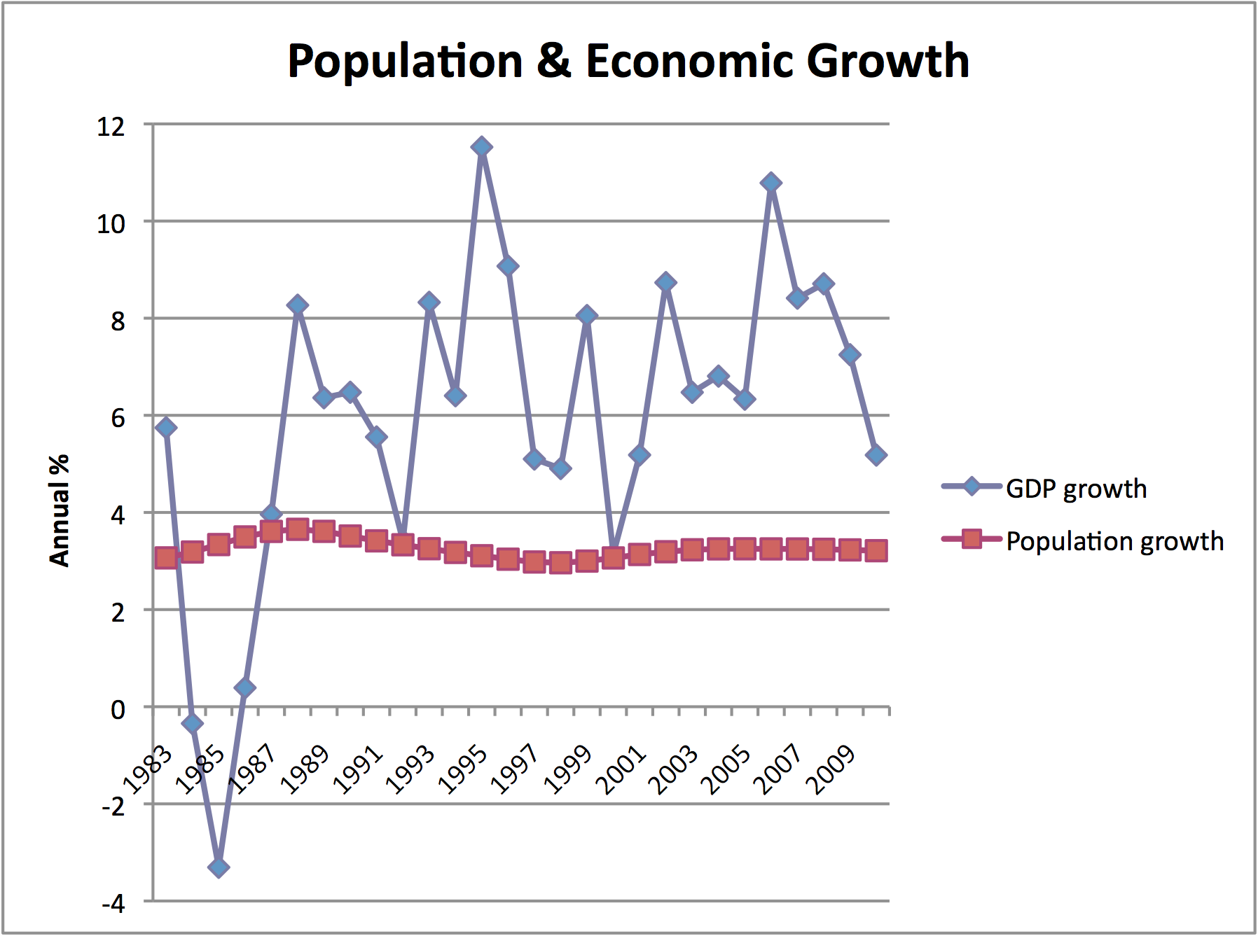
*Source: World Bank, “World Development Indicators.”

Conclusions
This chapter has shown how and why maintaining a tight grip on power comes at painful cost. In the absence of political competition, the temptation of self-preservation and self-enrichment become overwhelming. Both dynamics are illustrated well by the Museveni case. In fact, the narrative highlights how reinforcing these two agents are. With self-preservation secured, governments proceed towards self-enrichment. Absent auditors, parliaments, or opposition parties to stop them, leaders can pillage national coffers at will. The result, however, is a growing public backlash. No government, no matter how repressive, can fully hide the diversion of public wealth towards personal gain. Rumours circumvent even the tightest media controls. And while the public is in no position to halt the self-enrichment, it will take to the streets more and more frequently in order to express its grievances. This will in turn inspire the iron grip to squeeze even tighter, as the regime works harder still to ensure its self-preservation. The consequence of this clamping down will either spark a greater public challenge, plunging the country into civil war, or provide leaders an even freer path to pursue their personal gains. Either way, tensions will continue to fester, perhaps to the point of national emergency, from where the cycle can begin again.
The tragic consequence of leadership sclerosis is a dramatic deterioration of the regime’s ability to deliver fair and effective governance. This in turn greatly reduces the prospects for the economic growth that is so vital to the eradication of deep poverty. Physical coercion and co-option cost dearly, as do corruption and the outright pilfering of state resources. Income growth cannot reach its full potential when such behaviour runs rampant. Further research will be required to determine why the pace of sclerosis varies from one circumstance to the next. A closer examination of the relationship between corruption and economic growth might help explain this. Additional study is also needed to uncover the calculations behind a leader’s decision to remain in office. Here we have discussed the effects of prolonged rule; next is to determine when and why a leader chooses to cling to power in the first place. In the meantime, there is much to fret over the plight of Uganda’s people. The country faces policy aimlessness and worsening graft. Poverty reduction has been imperiled by a deteriorating leadership that has helped stall economic growth. Worst of all is the travesty that while Africa is currently undergoing a renaissance unseen since the 1960s, observers of Uganda’s economic outlook are remarkably gloomy. For a region with a future so bright, the people would be right to expect better.

Cited in The Economist, “Ruling Uganda,” (August 4, 2008).
Henry Kyemba, State of Blood, (London: Corgi, 1977).
Martin Meredith, Fate of Africa: A History of the Continent Since Independence, (New York: PublicAffairs, 2011), p238.
Plato, The Republic of Plato, F.D. Cornford (trans), (New York: Oxford University Press, 1962).
“During organizational crises…when organizations need to be turned around quickly, autocratic and directive leadership is needed. Sometimes unpopular decisions are required.” Bernard Bass, The Bass Handbook of Leadership, (New York: Free Press, 2008), p445.
J.A. Cammelleri, H.W. Hendrick, and W.C. Pittman, “Effects of Different Leadership Styles on Group Accuracy,” Journal of Applied Psychology, 57 (1973), p32-37. As Bass notes, “The captain’s individual judgement may be better than the sailors’ consensus.” Bass, Handbook, p451.
World Bank, “World Development Indicators.”
R. Likert, Past and Future Perspectives on System, 4, Paper, Academy of Management, Orlando, Fl, found that in laboratory experiments, in the short run authoritarian supervision pays off in higher productivity than does democratic supervision. However, in the long run democratic approaches tend to generate bigger improvements in an organization’s productivity, along with the satisfaction of its employees.
Bass, Handbook, p440, speaking of R.D. Smither, “The return of the authoritarian manager,” Training, (November, 1991), p40-43; and R.D. Smither, Authoritarian Management revisited: Participation, Organizational Effectiveness, and the Leader’s Appeal to Emotion.
R.C. Day and R. L. Hamblin, “Some Effects of Close and Punitive Styles of Supervision,” American Journal of Sociology, 69 (1964), p499-510; R. de Charms and R.L. Hamblin, Structural Factors and Individual Needs in Group Behavior, (St. Louis: Washington University Press, 1960).
Cammalleri, Hendrick, Pittman, et al, 1973.
The jet may be able to ferry 18 passengers in luxurious comfort at 559mph, but it does nothing to comfort the million who remained mired in deep poverty. Ian Drury, “UK aid cash helped African dictator buy himself a £30m jet,” MailOnline, (June 10, 2011).
Joseph Nye, The Power to Lead, (Oxford: Oxford University Press, 2008); Jean Hartley, “Political Leadership,” in S. Brookes and K. Gring (eds), The Public Leadership Challenge, (London: Palgrave, 2010). As one of the leading chroniclers of the leadership literature, Bernard Bass has remarked that “So far, analyses of power and corruption have been left to investigative journalists and the legal profession.” Bass, Leadership, p290.
The political leader is most often used as an illustrative case, rather than an analytical category. Jean Hartley and John Benington, in Alan Bryman et al (eds), The Sage Handbook of Leadership, (Los Angeles: Sage, 2011), p203. A few notable exceptions are the works of P. John, “Local Government Reform and Political Leadership,” in S. Brookes and Keith Grint, The Public Leadership Challenge; (London: Palgrave, 2010; T. Wren, Inventing Leadership: The Challenge of Democracy, (Cheltenham: Edward Elgar, 2007); Jean Blondel, Political Leadership: Towards a General Analysis, (London: Sage, 1987); J.M. Burns, Leadership, (New York: Harper Collins,, 1978); and R. Tucker, Politics as Leadership, (Columbia: University of Missouri Press, 1995). An illustration of how little theorizing is done on the topic comes from the fact most introductory texts ignore political leadership completely.
Human Rights Watch, Angola: Some Transparency, No Accountability. The Use of Oil Revenue in Angola and Its Impact on Human Rights, (New York, 2004).
In 2000, income per head was $310, a figure less than a third it had been in 1980. Half the population lived on less than 30 cents a day; half had no access to safe drinking water; and almost a fifth of children died before their fifth birthday. Meredith, Fate, p580.
Cited in Meredith, Fate, p704.
Cited in Meredith, Fate, p698. Overall, an estimated $850 billion has been siphoned from Africa since 1970.
Cited in Meredith, Fate, p685.
For further surveys on Uganda, see David E. Apter, The Political Kingdom in Uganda, (Princeton: Princeton University Press, 1967); Basil Davidson, A History of East and Central Africa to the 19th Century, (Garden City, NY: Anchor Books, 1969); Vincent Harlow and E.M. Chilver (eds), History of East Africa, (London: Oxford University Press, 1976). Kenneth Ingham, The Making of Modern Uganda, (Westport, CT: Greenwood Press, 1983); Samwiri Rubaraza Karugire, A Political History of Uganda, (Exeter, NH: Heinemann Educational Books, 1980); G.S.K. Ibingira, The Forging of an African Nation: The Political and Constitutional Evolution of Uganda from Colonial Rule to Indpendence, 1894-1962, (New York: Viking Press, 1973); D.A. Low, Buganda in Modern History, (Berkeley: University of California Press, 1971); D.A. Low and Robert Cranford Pratt (eds), Buganda and British Overrule, 1900-1955, (Nairobi: Oxford University Press, 1960); Bethwell A. Ogot and J.A. Kiernan (eds), Zamani: A Survey of East African History, (New York: Humanities Press, 1968); Amii Omara-Otunnu, Politics and the Military in Uganda, 1890-1985, (New York: St. Martin’s Press, 1987); George Ivan Smith, Ghosts of Kampala, (London: Weidenfeld and Nicolson, 1980); John Hanning Speke, Journal of the Discovery of the Source of the Nile, (London: Blackwood, 1864. Reprint New York: Greenwood Press, 1969); Henry M. Stanley, Through the Dark Continent, (New York: Harper, 1879. Reprint. New York: Greenwood Press, 1969); Godfrey Ondoga Ori Amaza, Museveni’s Long March: From Frelimo to the National Resistance Movement, (London: Pluto Press, 1998); Arne Bigsten and Steve Kayizzi-Mugerwa, Crisis, Adjustment and Growth in Uganda: A Study of Adaptation in an African Economy, (London: St. Martin’s, 1999); Yoweri Museveni, Sowing the Mustard Seed, (London: Macmillan, 1997).
Meredith, Fate, p236.
Meredith, Fate, p238. Some suggest the figure for the total death toll from 1981 to 1985 could be as high as 500,000. Rita M. Byrnes (ed), Uganda: A Country Study, (Washington: Library of Congress, 1992), p35.
Economist Intelligence Unit, Uganda: Country Profile, 2009, (London: Economist, 2009).
The Economist, “Bloody tyrant, now a good sort,” (August 21, 2003).
Ian Leggett, Uganda: An Oxfam Country Profile, (Oxford: Oxfam, 2001), p2.
The Economist, “Down, down, up, and maybe down,” (June 30, 2005).
Byrnes, Uganda, pxxii-xxiii.
Byrnes, Uganda, pxxvii.
The Economist, “Bloody tyrant, now a good sort,” (August 21, 2003). By 2003, 15,000 Asians were living in Uganda, investing an estimated $1 billion over the previous decade or so.
The Economist, “Down, down, up, and maybe down,” (June 30, 2005).
Primary enrolment grew from 3.4 million in 1996 to 7.4 million in 2004, and the rate for girls is now almost equivalent to that of boys. Secondary school enrolment jumped from 265,000 in 1998 to 698,000 by 2004. It has subsequently risen again, with the introduction of universal secondary education in 2007. Economist Intelligence Unit, Uganda: Country Profile, 2009, (London: Economist, 2009).
The Economist, “War, and rumours of war,” (October 17, 2002).
Meredith, Fate, p405.
Economist Intelligence Unit, Uganda: Country Profile, 2009, (London: Economist, 2009).
See World Bank, Poverty Reduction and Social Development Section, "Uganda: Recommendations for Strengthening the Government of Uganda's Anti-Corruption Program," (November 1998).
The Economist, “Reward for a falling star,” (December 17, 1998).
Meredith, Fate, p541.
See United Nations, “Panel of Experts on the Illegal Exploitation of Natural Resources and Other Forms of Wealth of the DRC,” (October 2003).
The Economist, “Reward for a falling star,” (December 17, 1998).
The Economist, “The shine fades on Museveni’s Uganda,” (April 29, 1999).
In this, what has been named the Temangalo corruption case, the ministers were found guilty by parliamentary committee. The ministers were, however, later exonerated by the Parliament itself, despite the substantial evidence against them.
The allegations were made by the Irish firm Tullow Oil. Geoffrey York, “Bill Gates urges transparency on oil deals in Uganda,” The Globe and Mail, (November 8, 2011).
Cited in The Economist, “Down, down, up, and maybe down,” (June 30, 2005). The report was by Joel D. Barkan et al, entitled “The Political Economy of Uganda: The Art of Managing a Donor-Financed Neo-Patrimonial State,” World Bank, (July 6, 2004).
A referendum was held on the multi-party question in June 2000, with over 90% of the voting public voting to retain with Movement system, on a turnout of about 50% nationally. Leggett, Uganda, p72.
Roughly 50% of the Ugandan national budget comes from overseas aid, and thus the pressure was keenly felt—no matter how strong Museveni’s reticence. The Finance Department’s Keith Muhakanizi suggests that without foreign aid fewer if any roads would have been rebuilt; and that free primary-school education would not be available to the 7 million children it is now. The Economist, “Down, down, up, and maybe down,” (June 30, 2005).
The Economist, “Tarnished Victory,” (March 15, 2001).
The Economist, “Tarnished Victory,” (March 15, 2001).
The Economist, “War, and rumours of war,” (October 17, 2002).
The Economist, “A long-standing leader’s mixed legacy,” (April 14, 2005). See Human Rights Watch, “State of Pain: Torture in Uganda,” (March 2004).
Britain’s response to Museveni’s intention to stay on was to cut $9 million US in aid as protest. The Economist, “Down, down, up, and maybe down,” (June 30, 2005). This abandoned his promise in 2001 to serve only two terms. The Economist, “A country adrift, a president amiss,” (February 12, 2009).
The Economist, “The limits of freedom,” (August 18, 2005).
Economist Intelligence Unit, Uganda: Country Profile, 2009, (London: Economist, 2009). The NRM was even more dominant in the subsequent parliamentary elections, winning 187 of the legislature’s 319 seats.
These charges were dismissed by the Constitutional Court as being unconstitutional in October 2011.
Amnesty International, Uganda: Annual Report, 2011, http://www.amnesty.org/en/region/uganda/report-2011, p1.
“But few doubt those mechanisms were in place.” The Economist, “Baobab: The old man of Kampala,” (February 21, 2011). Museveni has now been in power longer then Julius Nyerere of Tanzania, East Africa’s previous record holder.
The Economist, “Rambo reigns,” (February 24, 2011).
Alexis Okeowo, “Uganda Burning,” The New Yorker, (May 5, 2011). Fred Ojambo, “Ugandan Opposition Plans to Resume ‘Walk-to-Work’ Protests, Bloomberg, (January 17, 2012). Besigye then fled to Kenya for medical treatment after his fourth arrest that April alone.
Also noteworthy is that the police have tripled in size in recent years, to 40,000, and have been provided with heavy weapons training. The Economist, “A country adrift, a president amiss,” (February 12, 2009).
In 1986 and 1987 Freedom House awarded Uganda a score of 5 and 4 for political rights and civil liberties, respectively. The most recent results are the same, and have been for several years. Data available at Freedom House.org.
This measure “captures perceptions of the quality of public services, the quality of the civil service and the degree of its independence from political pressures, the quality of policy formulation and implementation, and the credibility of the government's commitment to such policies.” See “Worldwide Governance Indicators,” http://info.worldbank.org/governance/wgi/index.asp. Note that even the median figures suggest stagnation.
The anticipation is that Uganda could soon become a mid-sized producer, the likes of Mexico, in just a few years. Geoffrey York, “Bill Gates urges transparency on oil deals in Uganda,” The Globe and Mail, (November 8, 2011).
See John Kron “Uganda’s Oil Could Be Gift That Becomes a Curse,” New York Times, (November 25, 2011).
In 2006 there were 1.1 hospital beds available for every 1,000 people. By 2009, this had declined to just 0.394. World Bank, “World Development Indicators,” (2011).
Nicholas Bariyo, “Uganda Buys Fighter Jets,” Wall Street Journal, (April 7, 2011).
Sheila Naturinda, “Museveni Swearing-In to Cost Taxpayers $12.5 million,” Africa Review, (April 1, 2011).
Alexis Okeowo, “Uganda Burning,” The New Yorker, (May 5, 2011).
David Smith, “Yoweri Museveni Casts Foreign Media as Uganda’s Enemies Over Protest Coverage,” The Guardian, (May 19, 2011).
Joseph Were, “Museveni, Donors Lock Horns Over Election Money,” The Independent, (January 25, 2011).
Ioannis Gatsiounis, “Deadly Crackdown on Uganda's Walk-to-Work Protests,” Time, (April 23, 2011).
Life expectancy at birth was 50 in 1970, and 54 in 2010. United Nations Population Division; and UNICEF, “Information by Country: Uganda.”
Wolfgang Fengler, “The East African Ride to Middle Income,” Africa Can…End Poverty blog, (February 21, 2012), http://blogs.worldbank.org/africacan/the-east-african-ride-to-middle-income?cid=EXT_TWBN_D_EXT.
More precisely, starting from a per capita income of $528 US, and with continuation of current GDP and population trends, the real rate of per capita growth would be 4% a year, and require 17 years to break through the $1000 middle income threshold.
Economist Intelligence Unit, Uganda: Country Profile, 2009, (London: Economist, 2009).
The Economist, “Africa’s Hopeful Economics: The Sun Shines Bright,” (December 3, 2011).

